4/25/2018
Analysis Document Gallery Information System Development Project for the Tel Aviv Museum of Arts

Phase 3
Compiled by: Group 55 - The Nerd Herd
A. P. Barnard 28430093
W. G. Odendaal 28975383
J. A. van der Walt 28467078

Table of Contents
1. Project Description and System Requirements 1
2. Use-case list and high-level use-case narratives 2
2.1. Use-case list 2
2.2. Use-case narratives 4
2.3. Use-case diagram 5
3. Context data model 6
4. Key based data model 7
5. Fully Attributed data model 8
6. CRUD Matrix 9
7. Process models 11
8. Prototypes 12
8.1. Artist 12
8.2. Artwork 13
8.3. Sales 14
8.4. Clients 15
8.5. Reports 16

Project Description and System Requirements
The new information system is designed for a small gallery. The system will improve the performance and communication by using an integrated and uniform system that will support the information system.
System requirements
Artwork: The system users (gallery assistant) will be able to:
- Add, update and delete any information regarding the artwork.
- Keep track of artwork that is for sale and artwork that was sold.
- Only specific system users who are granted access to the entire, or higher levels of the system can add, update and delete information regarding the artwork.
- The system will automatically update the corresponding database when changes was made.
Artist: The system users (gallery assistant) will be able to:
- Add, update, and delete the personal information of the artist whose work is currently on display.
- The artist will be notified when his/her artwork has been sold.
- The artist will not have any direct access to the system. Any information he/she requires; the system users will provide.
Sales: The system users (gallery assistant) will be able to:
- Scan the barcode of the art piece that is being sold.
- The system will display price, commission, tax and other relevant information, regarding the sale of the artwork.
- The system will generate and print proof of payment slips.
- The system will update the corresponding database and notify the artist.
Client: The system users (gallery assistant) will be able to:
- Add, update, and delete the personal information of the client who has bought artwork or have outstanding depts.
- The system will update the corresponding database when there are changes, such as client buying artwork or paying of outstanding dept.
- The clients will not have any direct access to the system. Any information he/she requires; the system users will provide.
Reporting:
The system users (gallery assistant) will be able to:
- Generate the monthly reports.
The system owners will be able to:
- View the financial reports to see if the gallery is making a profit and to see if they can pay off debts.
- View the client reports to see how many client accounts are paid and how many are outstanding.
- View the artwork inventory to make sure all the artwork is accounted for.
- View the inventory to see if there is enough cleaning supplies and shipping materials.
- Keep track of inventory, such as varnish, cleaning materials and delivery materials.

2. Use-case list and high-level use-case narratives

Use-case list
User-case Name | User-case description | Participating Actors and Roles
Create artist account | The use case describes the event of a new artist providing his personal information to be added to the system as well as the artwork information.  The system user then creates an account. | New artist (primary business actor)  Assistant/system user (Primary system actor)
Create artist banking account | The use case describes the event of a artist providing all the information regarding his banking information so that it can be added to the system. | New artist (primary business actor)  Assistant/system user (Primary system actor)
Maintain art collection | The use case describes the event when a the assistant add, update or delete the collection. | Assistant/system user (Primary system actor)
Maintain artist account | The use case describes the event when a the assistant add, update or delete the artist account. | Assistant/ system users (Primary system actor)
Process sales | The use case describes the event that when a client has bought a artpiece and the assistant process the sale and notified the artist. | Artist (primary business actor)  Assistant/ system user (Primary system actor)
Maintain banking accounts | The use case describes the event when a the assistant update the banking account details. | Assistant/ system user (Primary system actor)
Maintain artwork information | The use case describes the event when a the assistant add, update or delete the artwork information. | Assistant/ system user (Primary system actor)
Maintain medium information | The use case describes the event when a the assistant add or update the medium information | Assistant/ system user (Primary system actor)
Create client account | The use case describes the event of a new client providing his personal information to be added to the system.  The assistant then creates an account. | New client (primary business actor)  Assistant/ system user (Primary system actor)
Provide client city details | The use case describes the event of a client providing all the information regarding his city details so that it can be added to the system. | New client (primary business actor)  Assistant/ system user (Primary system actor)
Maintain client account | The use case describes the event when a the assistant update the city account details. | Assistant/ system user (Primary system actor)
Process sales | The use case describes the event of a client buying artwork. | Client (primary business actor)  Assistant/ system user (Primary system actor)
Generate yearly and Monthly reports | The use case describes the event where the yearly and monthly report is generated automatically on a specific date.  The system owner receives this specific reports. | Owner (External receiver actor)  Time (Initiating actor)
Generate report | The use case describes the event  when the owner can generates any reports he\she whishes to see. | Owner (External receiver actor)

Use-case narratives
Author (s): Odendaal W.G  Van der Walt J.A.  Barnard A.P |  | Member Service System | Date: 14 April 2018  Version : 1.0
Use-Case Name: | Add new clients |  | Use-Case Type  Business Requirements: ☒
Use-Case ID: | TAMA-ADC0001 |  | Use-Case Type  Business Requirements: ☒
Priority: | High |  | Use-Case Type  Business Requirements: ☒
Source: | New Client |  | Use-Case Type  Business Requirements: ☒
Primary Business Actor: | New Client
Other Participating Actor: | Sytem user (primary system actor) – interested in ading the client to the system  Client (external receiver actor) – intersted in joining the galery community
Other Interested Stakeholders: | Owner Interested in expanding the galery’s clientbase.
Description: | The use case describes the event of when the gallery asistant adds a new client to the system.  - The assistant collects the new client’s information .  - The client is aded to the system and can then do purchases etc.

Author (s): Odendaal W.G  Van der Walt J.A.  Barnard A.P |  | Member Service System | Date: 14 April 2018  Version : 1.0
Use-Case Name: | Buy artwork from gallery |  | Use-Case Type  Business Requirements: ☒
Use-Case ID: | TAMA-BUY0001 |  | Use-Case Type  Business Requirements: ☒
Priority: | High |  | Use-Case Type  Business Requirements: ☒
Source: | Client |  | Use-Case Type  Business Requirements: ☒
Primary Business Actor: | Client
Other Participating Actor: | Sytem user (primary system actor) – interested in processing of the sale  Artist (external receiver actor) – intersted in the sales activity to receive benefits from sales  Gallery (external receiver actor) – interested in the sales activity to update inventory
Other Interested Stakeholders: | Owner – Interested in sales activity to receive funds and to exchange inventory
Description: | The use case describes the event of a client is buying artwork.  - The client provides their personal information to be added to the database.  - The assistant processes the sales transaction.  - After transaction was completed the corresponding databases is updated - remove the artpiece from the gallery’s inventory.  - The system then notifies the artist about the sales transaction.

Use-case diagram

System
System owner
Generate report
Process sales

Artist
Create artist account

Maintain artist account
Process sales
Maintain client account
System
user
Create client account

Provide client city details

Generate yearly and Monthly reports

Clients
Maintain art collection

Create artist banking account

Maintain banking accounts
nt
Maintain artwork information

Maintain medium information

Time

Context data model

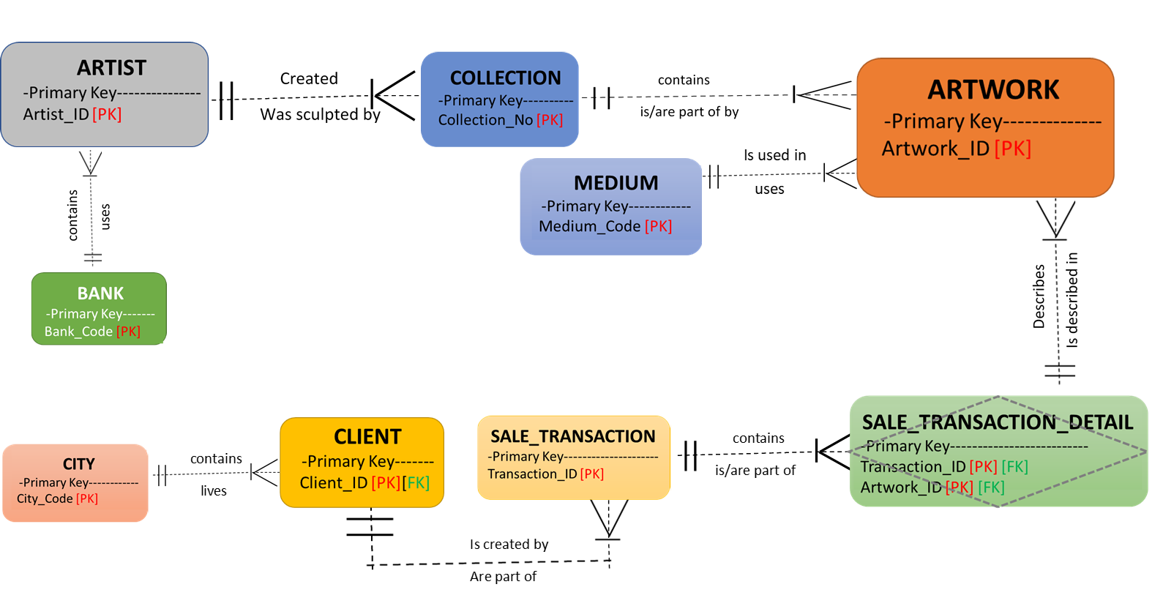
Key based data model

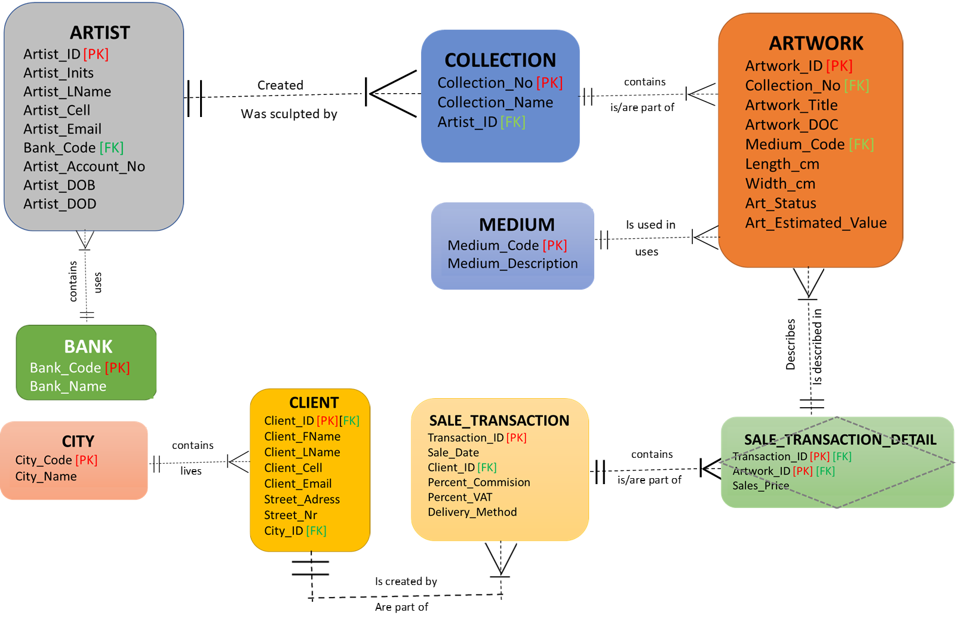
Fully Attributed data model
Artist_ID [FK]

CRUD Matrix
Entity .Attributes |  | Location |  | New Artist |  | Current +Artist | Gallery Manager |  | Gallery Assistant | New Client |  | Current Clients | Accounts Receivable | Accounts Payable | Owner
Artist |  |  |  | INDV |  | INDV | ALL |  | INDV | X |  | X | X | X | ALL
.Artist ID |  |  |  | R |  | R | CRUD |  | CRU | X |  | X | X | X | CRUD
.Artist Initials |  |  |  | R |  | R | CRUD |  | CRU | X |  | X | X | X | CRUD
.Artist Last Name |  |  |  | R |  | R | CRUD |  | CRU | X |  | X | X | X | CRUD
.Artist Cell |  |  |  | R |  | R | CRUD |  | CRU | X |  | X | X | X | CRUD
.Artist Email |  |  |  | R |  | R | CRUD |  | CRU | X |  | X | X | X | CRUD
.Artist Account Number |  |  |  | R |  | R | CRUD |  | CRU | X |  | X | X | X | CRUD
.Artist Date of Birth |  |  |  | R |  | R | CRUD |  | CRU | X |  | X | X | X | CRUD
.Artist Date of Death |  |  |  | R |  | R | CRUD |  | CRU | X |  | X | X | X | CRUD
Collection |  |  |  | ALL |  | ALL | ALL |  | SS | ALL |  | ALL | X | X | ALL
.Collection Number |  |  |  | R |  | R | CRUD |  | RU | X |  | X | X | X | CRUD
.Collection Name |  |  |  | R |  | R | CRUD |  | RU | R |  | R | X | X | CRUD
Artwork |  |  |  | INDV |  | ALL | ALL |  | ALL | ALL |  | ALL | X | X | ALL
.Artwork ID |  |  |  | R |  | R | CRUD |  | R | X |  | X | X | X | CRUD
.Artwork Title |  |  |  | R |  | R | CRUD |  | RU | R |  | R | X | X | CRUD
.Artwork Date of Creation |  |  |  | R |  | R | CRUD |  | RU | R |  | R | X | X | CRUD
.Length |  |  |  | R |  | R | CRUD |  | RU | R |  | R | X | X | CRUD
.Width |  |  |  | R |  | R | CRUD |  | RU | R |  | R | X | X | CRUD
.Art Status |  |  |  | R |  | R | CRUD |  | R | R |  | R | X | X | CRUD
.Art Estimated Value |  |  |  | R |  | R | CRUD |  | R | R |  | R | X | X | CRUD
Client |  |  |  | X |  | X | ALL |  | SS | INDV |  | INDV | X | X | ALL
.Client ID |  |  |  | X |  | X | CRUD |  | CR | R |  | R | R | R | CRUD
.Client First Name |  |  |  | X |  | X | CRUD |  | CR | R |  | R | R | R | CRUD
.Client Last Name |  |  |  | X |  | X | CRUD |  | CR | R |  | R | R | R | CRUD
.Client Cell |  |  |  | X |  | X | CRUD |  | CRU | R |  | R | R | R | CRUD
.Client Email |  |  |  | X |  | X | CRUD |  | CRU | R |  | R | R | R | CRUD
.Street Adress |  |  |  | X |  | X | CRUD |  | CRU | R |  | R | R | R | CRUD
.Street Number |  |  |  | X |  | X | CRUD |  | CRU | R |  | R | R | R | CRUD
Bank |  |  |  | INDV |  | INDV | ALL |  | X | INDV |  | INDV | ALL | ALL | ALL
.Bank Code |  |  |  | R |  | R | CRUD |  | X | R |  | R | CRUD | CRUD | CRUD
Entity .Attributes |  | Location |  | New Artist |  | Current Artist | Gallery Managegers |  | Gallery Assistant | New Client |  | Current Clients | Accounts Receivable | Accounts Payable | Owner
.Bank Name |  |  |  | R |  | R | CRUD |  | X | R |  | R | CRUD | CRUD | CRUD
Medium |  |  |  | ALL |  | ALL | ALL |  | ALL | X |  | X | X | X | ALL
.Medium Code |  |  |  | R |  | R | CRUD |  | CRU | X |  | X | X | X | CRUD
.Medium Description |  |  |  | R |  | R | CRUD |  | CRU | X |  | X | X | X | CRUD
City |  |  |  | ALL |  | ALL | ALL |  | ALL | ALL |  | ALL | X | X | ALL
.City Code |  |  |  | R |  | R | CRUD |  | CRU | R |  | R | X | X | CRUD
.City Name |  |  |  | R |  | R | CRUD |  | CRU | R |  | R | X | X | CRUD
Sale Transaction |  |  |  | X |  | X | ALL |  | ALL | INDV |  | INDV | ALL | ALL | ALL
.Transaction ID |  |  |  | X |  | X | CRUD |  | CRU | R |  | R | R | R | CRUD
.Sale Date |  |  |  | X |  | X | CRUD |  | CRU | R |  | R | R | R | CRUD
.Percent Commision |  |  |  | X |  | X | R |  | R | X |  | X | RU | RU | CRUD
.Percent VAT |  |  |  | X |  | X | RU |  | R | X |  | X | RU | RU | CRUD
.Delivery Method |  |  |  | X |  | X | CRUD |  | CRU | CR |  | R | R | R | CRUD
Sale Transaction Detail |  |  |  | INDV |  | INDV | ALL |  | ALL | INDV |  | INDV | ALL | ALL | ALL
.Transaction ID |  |  |  | R |  | R | CRUD |  | CRU | R |  | R | RU | RU | CRUD
.Artwork ID |  |  |  | R |  | R | CRUD |  | CRU | R |  | R | RU | RU | CRUD
.Sales Price |  |  |  | R |  | R | CRUD |  | RU | R |  | R | RU | RU | CRUD
.Artist ID |  |  |  | R |  | R | CRUD |  | CRU | R |  | R | RU | RU | CRUD
 | INDV = Individual |  | ALL = All |  | SS = Subset |  |  | X = No access
 | S = Submit |  | C = Create |  | R = Read |  |  | U = Update |  |  | D = Delete

7. Process models

8. Prototypes

8.1. Artist

Database containing different artist information
Database containing specific artist’s collection

Personal information
Collection

2
1

3
Artwork information
Name of Artist:
Date of Birth:
Date of Death:
Title of artwork:
Completion date:
Medium:
Dimensions:
Frame type:
Collection name:
Estimate:

Finish
Artist information
First name:
Last name:
Telephone no.:
e-mail:
Bank account:

Finish
Artist
4
Search:

Update

Delete

\
Add
Search:

Update

Delete

\
Add
Step 1:
When the system user clicks on the artist tab, this window will be displayed.
System user can then view the artist database which will contain all the artist personal information.

Step 2:
The database containing all the artist collection will be displayed.

Step 3:
When the system user searches for a specific artist ID, only that artist information will be displayed in the database along with the artist collection.

Step 4:
The artist ID needs to be search before the system user can, update or delete information.
When the user clicks on any of these buttons, a second window will open where you can add a new record, update or delete an existing record.

3
4

8.2. Artwork

Database containing different artwork information
Art pieces

1

2
Artwork
Search:

Step 1:
When the system user clicks on the Artwork tab, this window will be displayed.
System user can then view the Artwork database which will contain all the art information.

Step 3:
When the system user searches for a specific Artwork ID, only that artwork information will be displayed in the database.

Note: The add, update and delete function was featured in the Artist window (previous page).

3

8.3. Sales

Step 1:
When the system user clicks on the sales tab, this window will be displayed.
System user can then view the sales database which will contain all the sales information.

Step 2:
When the system user clicks on the add sales button, this window will be displayed.
System user can then add the new sale to the database.

Step 3:
When the system user clicks on the sale history button, the database containing the history of all the sales will be displayed.

Sales
Database sales information

Summary of sales
Sale Information
Barcode:
Date of sale:
Price:
Commission:

Add sale
Add sale
Sale history
1v
2v
3v

8.4. Clients
3
Search:

Update

Delete

\
Add

Step 1:
When the system user clicks on the client’s tab, this window will be displayed.
System user can then view the client’s database which will contain all the client’s personal information.

Step 2:
When the system user searches for a specific client, only that client’s information will be displayed in the database.

Step 3:
The client ID needs to be search before the system user can, update or delete information.
When the user clicks on any of these buttons, a second window will open where you can add a new record, update or delete an existing record.

Clients
Database client information

Client list
Client Information
ID:
First name:
Last name:
Telephone no.:
Address
Deliver method:

OK
1v
2v

8.5. Reports
1
2

Financial report
Client report
Artwork inventory reporting
Shipping Inventory reporting
Generate report:
Reporting
Step 1:
When the system user clicks on the reporting tab, this window will be display.

Step 2:
The system user can click on any button and the report will be generated.

